**X2GO CLIENT -TUTORIAL**

1. **Installation**
2. X2Go is program used to run graphical applications on our Linux machines remotely. This uses a different technology from remote X, which results in better performance, especially when not on campus. This also allows for suspending and resuming sessions and programs, while they continue to run. This allows the use of long-running graphical applications.
3. The X2Go Client software is already installed on all lab computers. For your personal computers, download the X2Go client for your operating system:
   1. macOS - <http://code.x2go.org/releases/X2GoClient_latest_macosx.dmg>
   2. Windows - <http://code.x2go.org/releases/X2GoClient_latest_mswin32-setup.exe>
4. On macOS, mount the dmg file (your browser may do this for you after download) and drag the x2goclient application to your Applications folder. On Windows, double-click the downloaded setup file and follow the instructions in the wizard to install the software.
5. **Configuration**
6. When you first run the X2Go client, you will be presented with a "***New session***" dialog. You should fill this in with this information:
7. Session tab
   1. Session name - Any name you'd like to identify the session to yourself - if you're connecting to ***i80labpc04.ira.uka.de***, you might just want this to be " ***i80labpc04***"
   2. Host - Full name of the server you're connecting to, e.g. ***i80labpc04.ira.uka.de***
   3. All of our compute machines have the X2Go server installed
   4. Login – Your user ID e.g. “***asip04***” (be careful to use lower case)
   5. Session type - Select XFCE (this is the only supported session type) - see below for an explanation of session types.

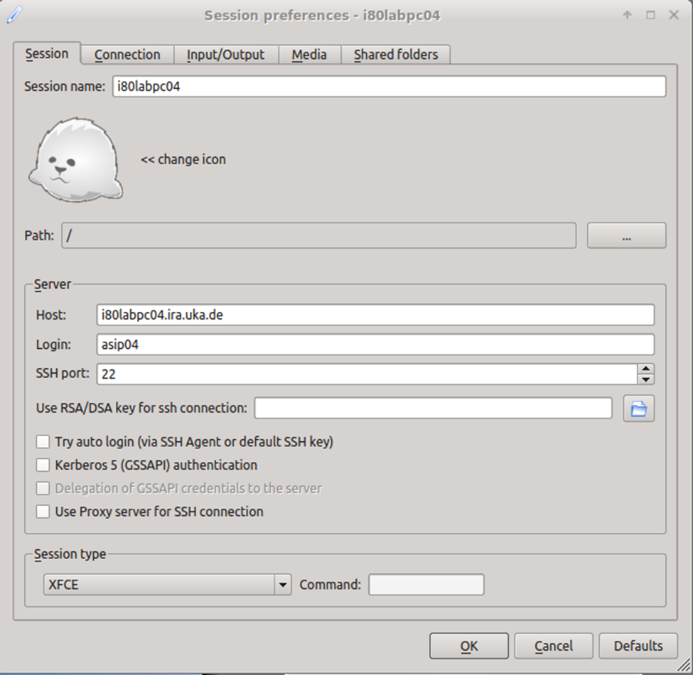

Figure 1: Session Tab

1. Connection tab
   1. Connection speed - Set the connection speed you will most often use for this connection
   2. The default ADSL is fine for most connections, but if you are on campus, you will get better graphics performance if you choose LAN

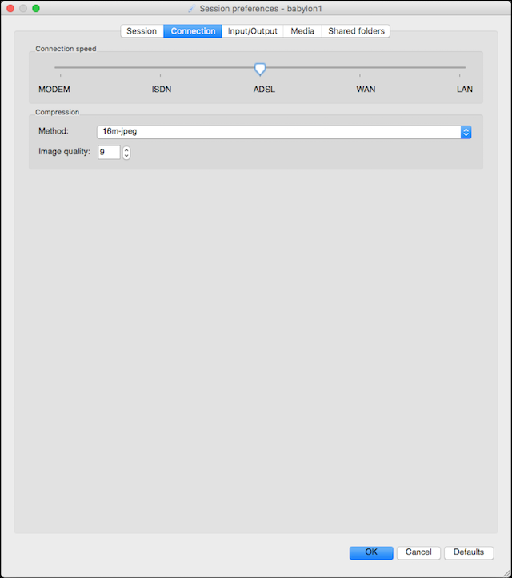

Figure 2: Connection Tab

1. Input/output tab
   1. Display - select whether you want to run full screen or at a specific resolution
2. Media
   1. Client side printing support - be sure to uncheck this box or you may get errors when starting the session

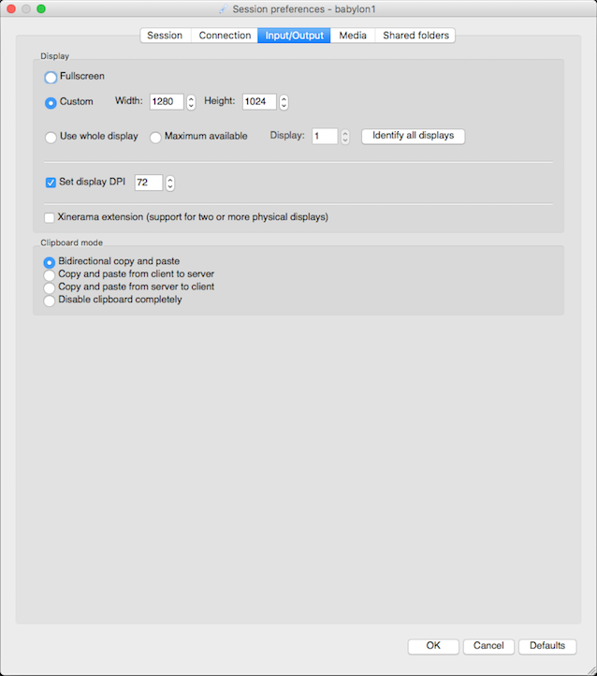

Figure 3: Input/output Tab

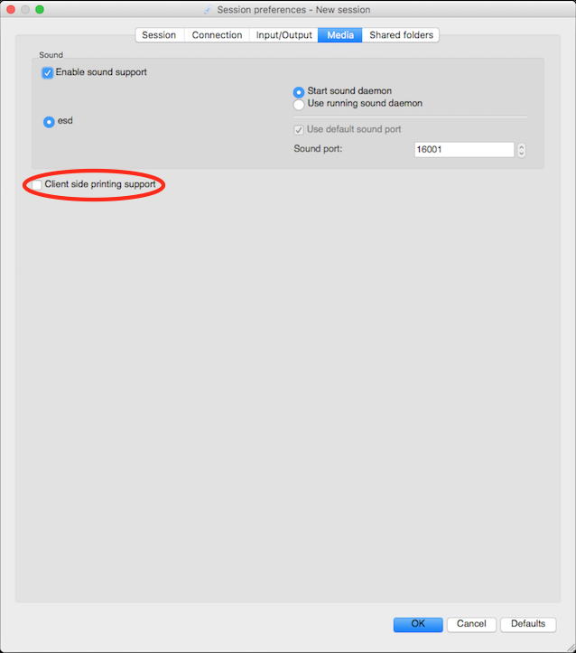

Figure 4: Media Tab

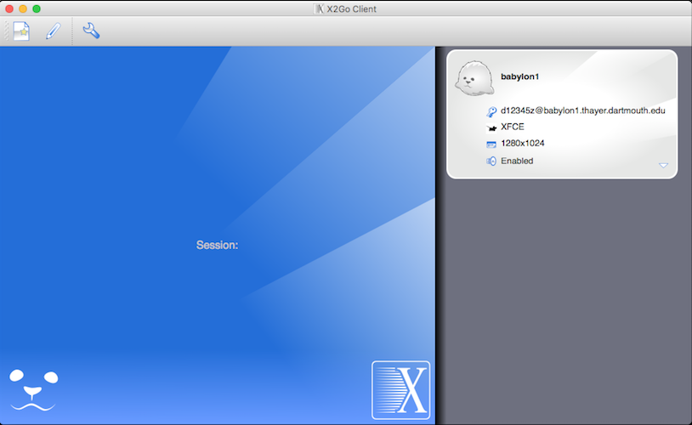

Figure 5: Main Client Screen

1. **Session Types**
2. The session types that we support are:
   1. XFCE (recommended) - This is a low-power window manager that is the only one supported in the current version of Ubuntu
   2. Published applications - This allows you to run one or more applications directly, rather than a full desktop session. See below for how to run published applications
3. **Connecting**
4. To start the session, click on it and provide your password where prompted

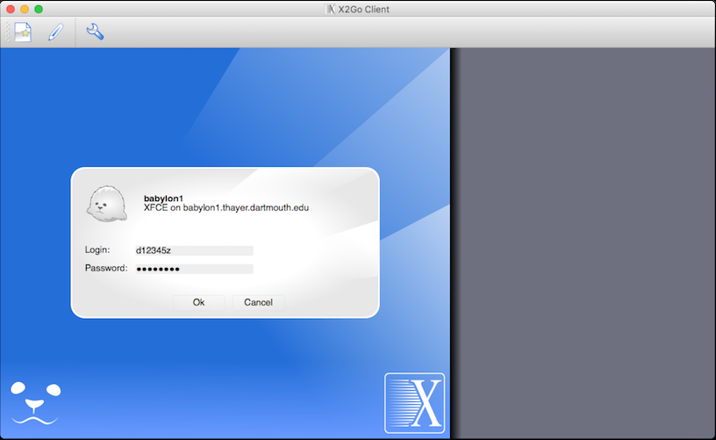

Figure 6: Login Screen

1. After you click OK, it will connect to the server and start your session. Watch the Status line to see what's happening. Once the status is "running," your session should launch.
2. When you first connect to a particular server, you may get a dialog box asking you to accept the host key. Click Yes to accept it:

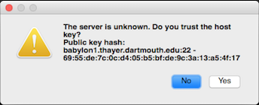

Figure 7: Host Key Authentication

1. To suspend a session, click the suspend button:

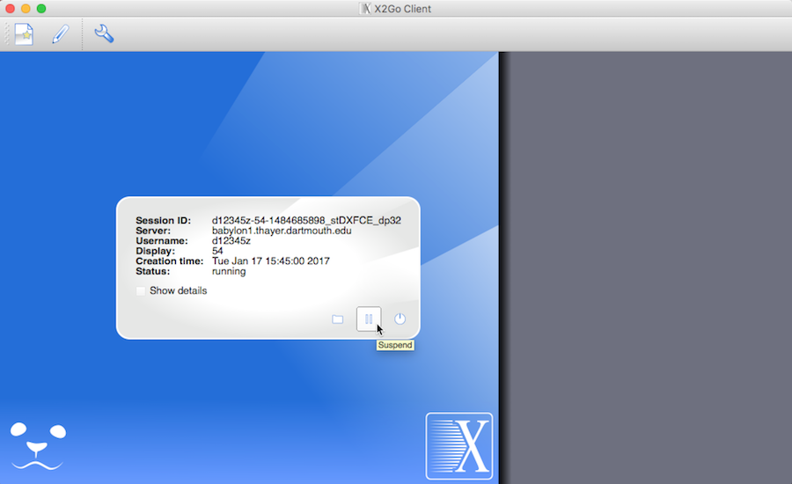

Figure 8: Suspending a Session

1. To terminate, either log out of your session or click the terminate button:

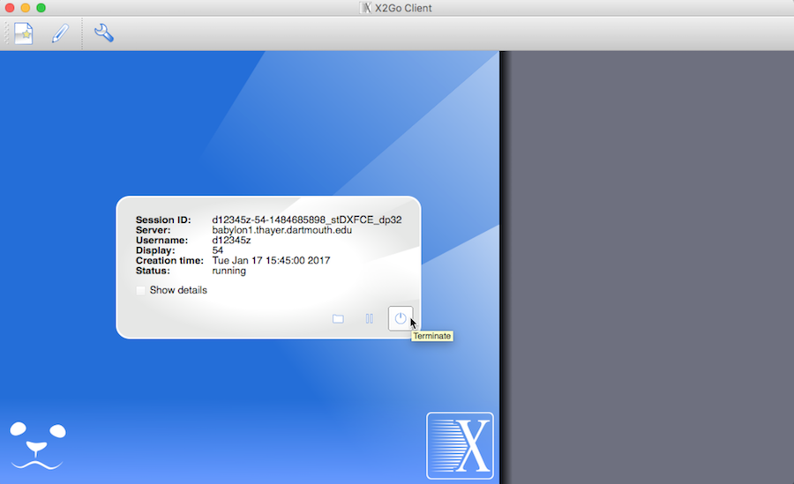

Figure 9: Terminating a Session

1. **Resuming**
2. If you have a single session open on a particular server and you reconnect with the same client, it will automatically re-connect to your session.
3. If you are connecting from a different client or have multiple sessions on the same server, you'll be presented a list to either resume an existing session or create a new one:

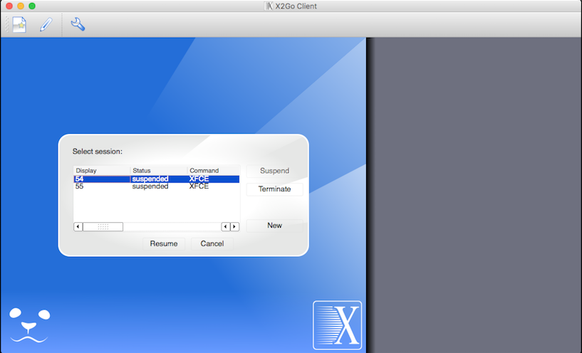

Figure 10: Resuming a Session

1. **Published Applications**
2. If you choose the "Published Applications" session, after you connect the Status will change to running, but it will appear that nothing has happened. To choose an application, click the "Applications" button:

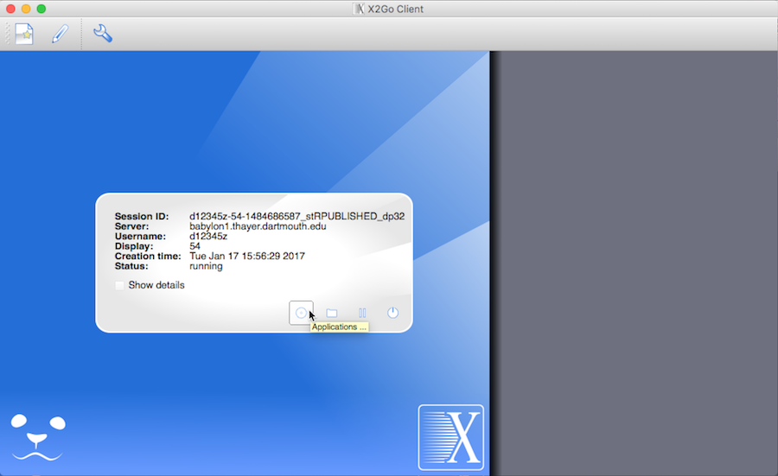

Figure 11: Published Applications

1. This will then bring up a dialog from which you can choose an application to run. All Thayer-specific applications are interspersed under the "Other" section:

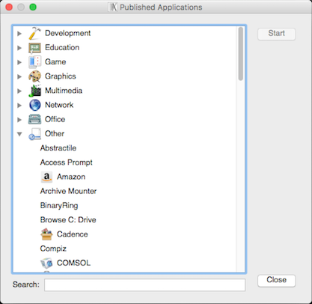

Figure 12: Applications

1. When you click "Start," be patient. This dialog does not go away and some programs may take several seconds to start up. Clicking Start more than once will launch multiple instances of the same app.
2. Fonts for Windows
3. When using the X2Go client on Windows, there may be some older programs (e.g. Cadence) where fonts do not show up properly. Symptoms you may see are either blocky, illegible fonts or instances where fonts disappear because they are white on a white background. If you experience any of these, you can install a font package that should eliminate most of these issues. Keep in mind that this is only needed if you are running the X2Go client on Windows.
4. First, if you haven't already, follow the instructions at Thayer Shares Connecting to connect to Thayer Shares. Navigate to the Courses share (P:), and go to the software\x2go folder. In this folder, double-click the vcxsrv_fonts.exe file to install the fonts. Depending on your security settings, you may need to drag this file to your local computer before double-clicking on it.
5. Other Settings
6. If you are using a Mac and need to use the Alt key within remote sessions, you need to change the X11 preferences. Run XQuartz directly from within Applications->Utilities. Then, select the X11->Preferences... menu item, select the Input tab, and check the box next to "Option keys send Alt_L and Alt_R." Close the preferences window and quit X11. Then, restart X2Go and when you log into a remote session, the option key (also labeled alt on most Mac keyboards) will send the Alt key to the remote side.

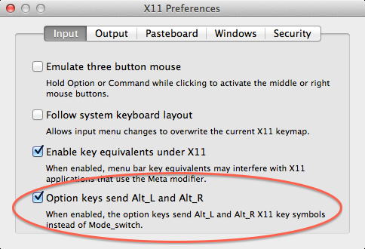

Figure 13: X11 Preferences